AWS APPLICATION LOAD BALANCER
Path-Based Routing — AWS Console Lab

Student Name | Sylvain Simo Kamdem
Course | UCT Cloud / DevOps Bootcamp
Instructor | Valery Nyandja
Assignment | Configure AWS ALB with Path-Based Routing
AWS Region | us-east-1
Date | August 11, 2026

1. Overview

This lab deploys four Ubuntu EC2 instances behind a single Application Load Balancer. The ALB uses path-based routing rules to direct /app1 requests to two App1 servers and /app2 requests to two App2 servers — both accessible through one DNS endpoint.

Browser → http://[ALB-DNS]/app1 or /app2
↓
Application Load Balancer (1 DNS, port 80)
↙ /app1* ↙ ↘ /app2* ↘
TG-App1 (app1-server-1, app1-server-2) TG-App2 (app2-server-1, app2-server-2)

2. Step 1 — VPC & Network

1. Go to VPC Console → Create VPC → select VPC and more
▶ Services → VPC → Your VPCs → Create VPC

Name tag | alb-path-lab
IPv4 CIDR | 10.0.0.0/16
AZs | 2
Public subnets | 2 (one per AZ)
Private subnets | 0
NAT / Endpoints | None

2. Click Create VPC — wait for all resources to show Created

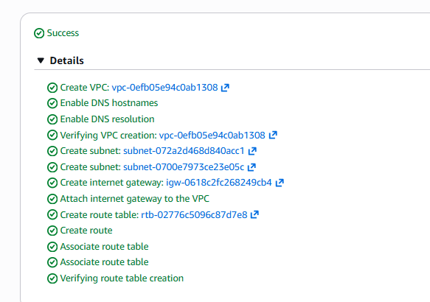

3. Step 2 — Security Groups

▶ VPC Console → Security Groups → Create security group

ALB Security Group
Name | alb-path-lab-alb-sg
VPC | alb-path-lab-vpc
Inbound | HTTP | TCP | 80 | 0.0.0.0/0

EC2 Security Group
Name | alb-path-lab-ec2-sg
VPC | alb-path-lab-vpc
Inbound rule 1 | HTTP | TCP | 80 | Source: alb-path-lab-alb-sg
Inbound rule 2 | SSH | TCP | 22 | 0.0.0.0/0

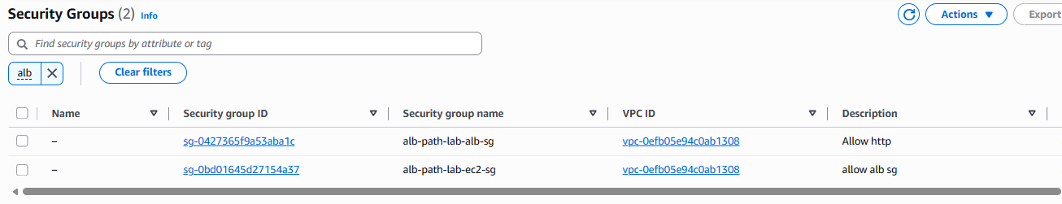

4. Step 3 — Launch 4 EC2 Instances

▶ EC2 Console → Instances → Launch Instances
Launch all four instances with these base settings, changing only Name and Subnet per server:

AMI | Ubuntu Server 26.04 LTS
Instance type | t3.micro
Key pair | your existing key pair
Security group | alb-path-lab-ec2-sg
Auto-assign Public IP | Enable

Instance Name | Subnet / AZ | App | User Data script
app1-server-1 | public-subnet-a (1a) | App1 | app1 script below
app1-server-2 | public-subnet-b (1b) | App1 | app1 script below
app2-server-1 | public-subnet-a (1a) | App2 | app2 script below
app2-server-2 | public-subnet-b (1b) | App2 | app2 script below

Paste the correct User Data in the Advanced details → User Data field when launching each instance:

# App1 User Data — paste for app1-server-1 and app1-server-2
#!/bin/bash
apt-get update -y
apt-get install -y apache2
systemctl start apache2
systemctl enable apache2
mkdir -p /var/www/html/app1
cat > /var/www/html/app1/index.html << 'EOF'
<!DOCTYPE html>
<html>
<head>
<title>Application 1</title>
<style>
body{
font-family: Arial, sans-serif;
text-align:center;
margin-top:100px;
background-color:#e8f4fd;
}
.container{
width:60%;
margin:auto;
padding:30px;
background:white;
border-radius:10px;
box-shadow:0px 0px 10px gray;
}
h1{
color:#0078d7;
}
</style>
</head>
<body>
<div class="container">
<h1>Welcome to Application 1</h1>
<h2>Path Accessed: /app1</h2>
<p>This request was routed by AWS ALB using Path-Based Routing.</p>
<p><strong>Target Group:</strong> TG-App1</p>
</div>
</body>
</html>
EOF

# App2 User Data — paste for app2-server-1 and app2-server-2
#!/bin/bash
apt-get update -y
apt-get install -y apache2
systemctl start apache2
systemctl enable apache2
mkdir -p /var/www/html/app2
cat > /var/www/html/app2/index.html << 'EOF'
<!DOCTYPE html>
<html>
<head>
<title>Application 2</title>
<style>
body{
font-family: Arial, sans-serif;
text-align:center;
margin-top:100px;
background-color:#fef3e2;
}
.container{
width:60%;
margin:auto;
padding:30px;
background:white;
border-radius:10px;
box-shadow:0px 0px 10px gray;
}
h1{
color:#ff6b00;
}
</style>
</head>
<body>
<div class="container">
<h1>Welcome to Application 2</h1>
<h2>Path Accessed: /app2</h2>
<p>This request was routed by AWS ALB using Path-Based Routing.</p>
<p><strong>Target Group:</strong> TG-App2</p>
</div>
</body>
</html>
EOF

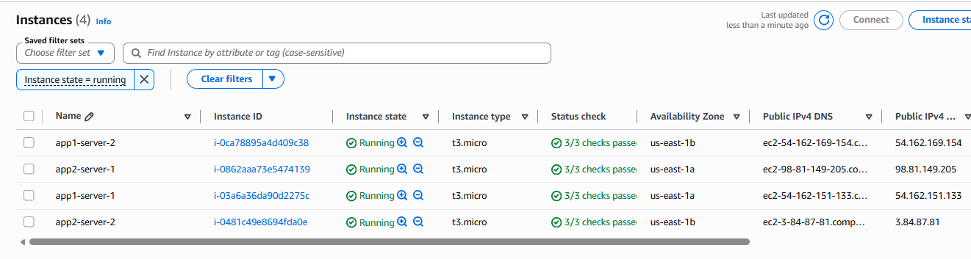

5. Step 4 — Create Target Groups

▶ EC2 Console → Load Balancing → Target Groups → Create target group

TG-App1
Name | TG-App1
Protocol / Port | HTTP / 80
VPC | alb-path-lab-vpc
Health check path | /app1/index.html
Targets to register | app1-server-1 and app1-server-2

TG-App2
Name | TG-App2
Protocol / Port | HTTP / 80
VPC | alb-path-lab-vpc
Health check path | /app2/index.html
Targets to register | app2-server-1 and app2-server-2

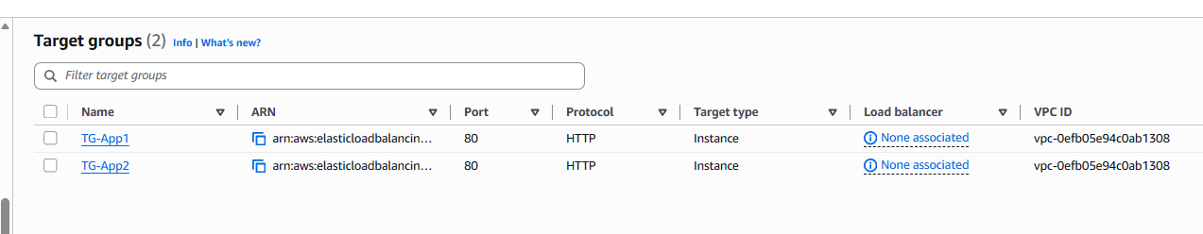

6. Step 5 — Create the Application Load Balancer

▶ EC2 Console → Load Balancing → Load Balancers → Create load balancer → Application Load Balancer

Name | alb-path-lab-alb
Scheme | Internet-facing
IP type | IPv4
VPC | alb-path-lab-vpc
Mappings | us-east-1a → public-subnet-a | us-east-1b → public-subnet-b
Security group | alb-path-lab-alb-sg (remove the default)
Listener | HTTP : 80 → default action: Forward to TG-App1 (temporary)

1. Click Create load balancer — wait for State: active
2. Record the ALB DNS name from the Details tab: alb-path-lab-alb-32948137.us-east-1.elb.amazonaws.com

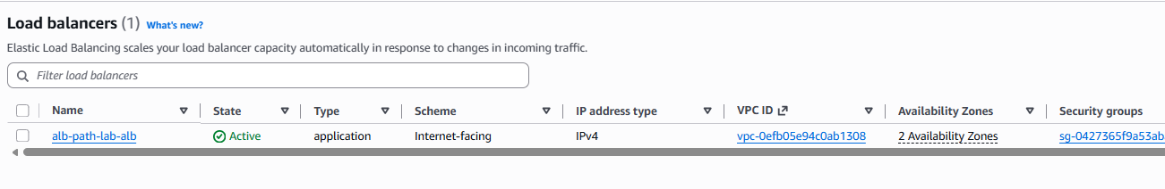

7. Step 6 — Add Path-Based Listener Rules

▶ EC2 → Load Balancers → alb-path-lab-alb → Listeners and rules tab → HTTP:80 → Manage rules → Add rule

Rule 1 — /app1 → TG-App1
Rule name | rule-app1
Priority | 1
Condition | Path is /app1*
Action | Forward to → TG-App1

Rule 2 — /app2 → TG-App2
Rule name | rule-app2
Priority | 2
Condition | Path is /app2*
Action | Forward to → TG-App2

Default Rule — No path match
Action | Return fixed response
Response code | 404
Response body | Page not found. Use /app1 or /app2

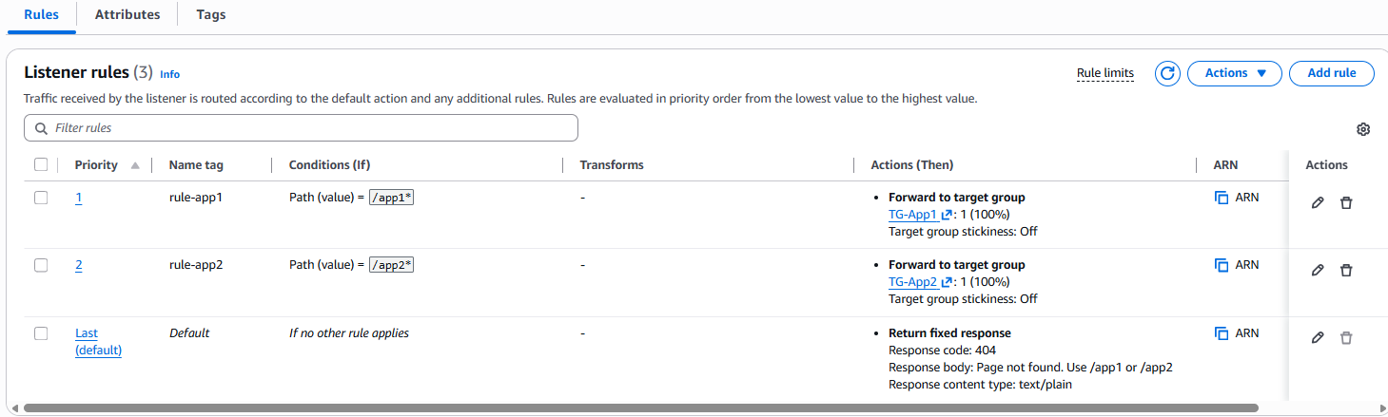

8. Step 7 — Verify Health & Test in Browser

8.1 Verify Target Health
▶ EC2 → Target Groups → select TG-App1 → Targets tab
Both targets must show Status: healthy before testing. Repeat for TG-App2.

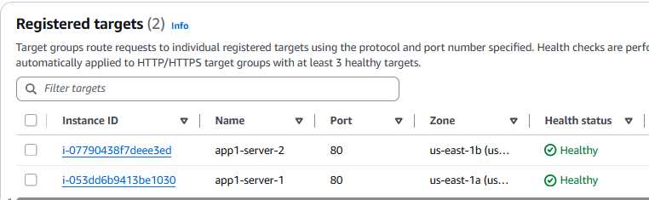
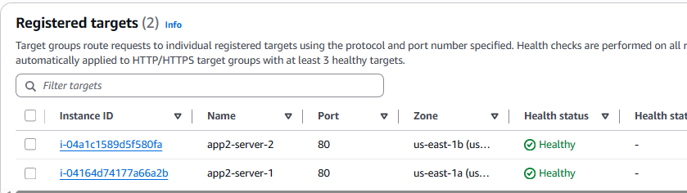

8.2 Browser Tests
Copy the ALB DNS name from EC2 → Load Balancers → Details tab, then test all three URLs:

URL | Expected Result | Rule triggered
http://alb-path-lab-alb-32948137.us-east-1.elb.amazonaws.com/app1/ | App1 HTML page loads | rule-app1 → TG-App1
http://alb-path-lab-alb-32948137.us-east-1.elb.amazonaws.com/app2/ | App2 HTML page loads | rule-app2 → TG-App2
http://alb-path-lab-alb-32948137.us-east-1.elb.amazonaws.com/ | 404 fixed response | Default rule

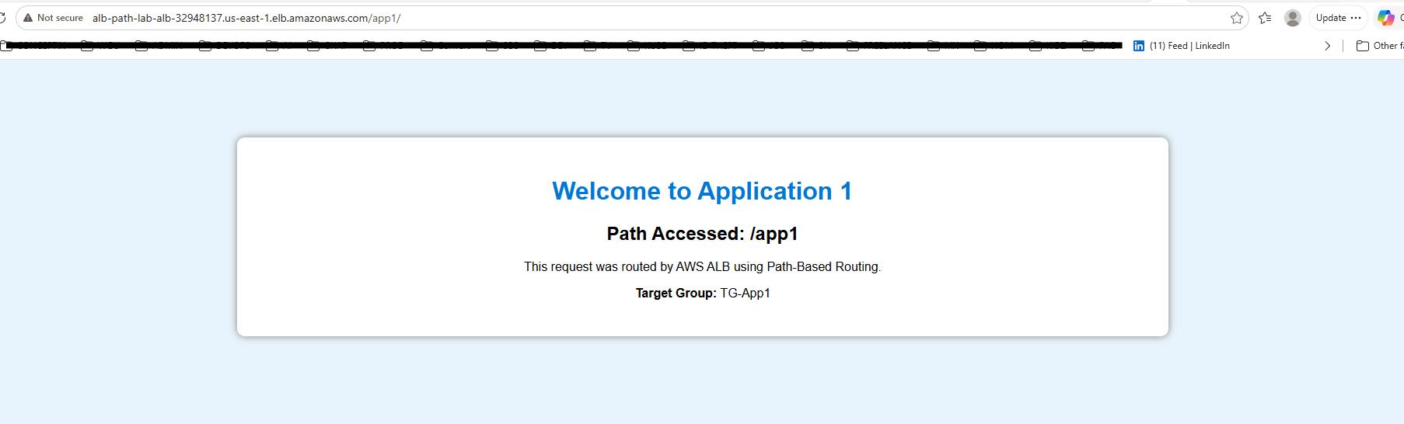

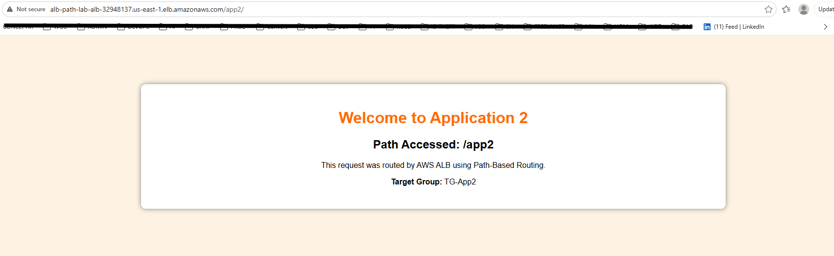

📝 If the same server responds on every refresh, open an incognito window or use Ctrl+Shift+R to bypass browser cache.

9. Cleanup

Delete resources in this order to avoid dependency errors:

# | Resource | Console Path
1 | Application Load Balancer | EC2 → Load Balancers → Actions → Delete
2 | Target Groups (TG-App1, TG-App2) | EC2 → Target Groups → Actions → Delete
3 | EC2 Instances (all 4) | EC2 → Instances → Instance State → Terminate
4 | Security Groups (both) | VPC → Security Groups → Actions → Delete
5 | VPC | VPC → Your VPCs → Actions → Delete VPC

10. Summary

The ALB path-based routing lab was completed successfully through the AWS Console. Key outcomes:

- 1 ALB with a single DNS endpoint serving both applications
- 2 listener rules routing /app1 and /app2 to separate target groups
- 4 Ubuntu EC2 instances (2 per app) across 2 Availability Zones
- Browser tests confirmed correct routing for /app1, /app2, and the default 404 rule

Sylvain Simo Kamdem
August 11, 2026

